# Andromeda

# Order Tracking Customer Guide

Contents

Order Tracking Customer View 3

Basic Concepts 3

Order Stages 3

Proximity Delivery concept 7

Web integration 8

Developer URLs 8

# Order Tracking Customer View

## Basic Concepts

The stores website will have a 'Track my order' area. A customer (after having placed an order) would type in their credentials, usually the phone number they ordered from, which would then give them access to their order details and the status of the order.

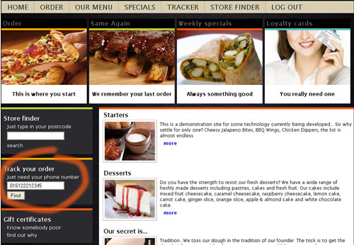

## Order Stages

The order has 5 stages that it goes through, a developer can easily translate these stages into visual cues such as demonstrated below. Again, the choice of graphics, styles are design decisions best taken by the store.

In order stages are:

1. Order taken

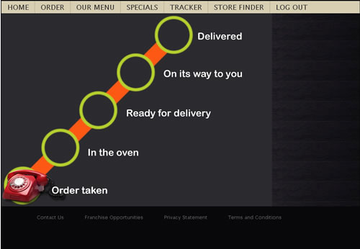

1. In Oven

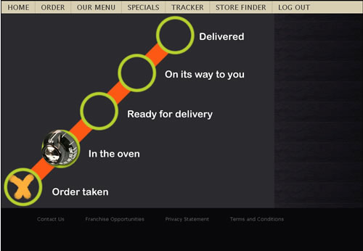

1. Cut (ready for delivery)

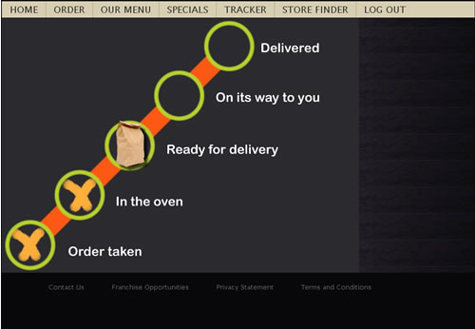

1. Out for delivery (if GPS is enabled, you can see progress on a map)

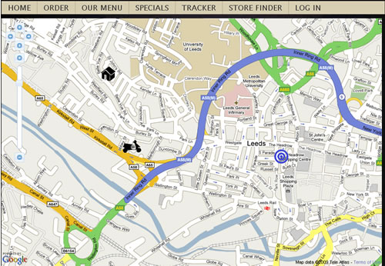

If the store has drivers with GPS trackers (aka GPS is enabled), then stage 4 (out for delivery) could be a map (eg. Google maps) that would show the stores location, the customers location, and the drivers location. This map should update every 10 seconds, since the trackers do not send information more often than every 10 seconds.

Once the driver is within 100 meters of the customers location, the order is flagged as 'proximity delivered' and it is suggested that tracking via the map should be suspended and the user is informed that the order is 'very close'. If the customer has been tracking the order, then the order being 'very close' would be obvious.

## The reasons for 'proximity delivery' are that the developers integrating the system can suspend driver tracking, after all you don't want display the drivers location on the way back to the store.

1. Cashed off (delivered)

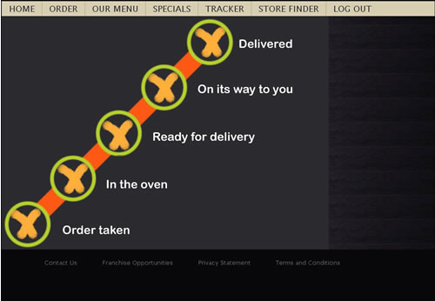

1. Cancelled

## Stores wishing to integrate GPS into their systems can do so easily by using the following URL as a starting point:

## <http://test.androtechnology.co.uk/Location/TrackMyOrder.aspx>

## Web developers integrating this system will also need this webservice url for testing:

<http://test.androtechnology.co.uk/Ordertracking/ExternalMapTracking.asmx>

For live releases:

<http://www.androtechnology.co.uk/Ordertracking/ExternalMapTracking.asmx>

calling the method ‘GetClientOrder’. The credentials required are usually the phone number the client used to phone the order in, or whatever the submitted client credentials were. Please see the developer documentation for more details.